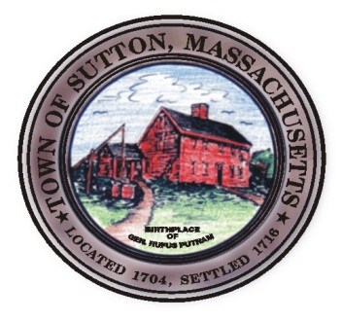
ZONING BOARD OF APPEALS

TOWN OF SUTTON ZONING BOARD OF APPEALS
4 UXBRIDGE ROAD · SUTTON, MA 01590 · (508) 865-8723 · FAX (508) 865-8721
MINUTES

January 5, 2017

Approved by: ___________________
Date: _________________________

Zoning Board Members Present: Rick Deschenes, Chairman; Brittanie Reinold, Clerk;
Michael McGovern; Richard Haskins; Stephanie Forsythe
Secretary: Lynn Dahlin

All others present: Stephen O’Connell, Andrews Engineering

7:30 pm- Public Hearing – 182 Manchaug Rd., T.J.J. Development
Finding / Variances

R. Deschenes read the public hearing notice as it appeared in the Millbury Sutton Chronicle.
Stephen O’Connell represented the applicant and explained that the Board previously approved the requested relief and it expired without a request for an extension. The applicant was now ready to move forward and they needed to legally go through the process again. The plan and requests in front of the Board presently were the same as was approved previously. The project involved the tear down and rebuild of the existing non-conforming dwelling. Lot Coverage would be less than the existing.
R. Deschenes asked if they were building the same home as was previously presented and it was stated that he was correct.
M. McGovern noted the tight tank and questioned the reason for it and it was answered that there was no room to comply due to well setbacks, water body, and land area and it was approved by the BOH.
S. O’Connell noted that the site plan spelled out the lot coverage for both the deck and the home which totaled 27.1%.
M. McGovern motioned, R. Haskins seconded and the vote unanimous to close the public hearing.

Decision: 182 Manchaug Rd.
S. Forsythe motioned, R. Haskins seconded and the vote unanimous to reapprove /reinstate the previous decision made October 1, 2015 for the variance and finding for 182 Manchaug Road as recorded in Bk: 54688 Pge:127 of the Worcester registry of deeds.

Board Business:
Meeting Minutes:
McGovern motioned, Stephanie Forsythe seconded and the vote unanimous to approve the minutes of the November 3, 2016 meeting.

7:45pm - Meeting Adjourned

Respectfully submitted,

Lynn Dahlin
BOA Secretary

